Q&A problem on contributions

Table of contents

1. How to fill in my declaration? 2

2. I have access to the portals but not to contributions, what should I do? 5

3. I get an error message when logging in. 5

4. How do I create a profile and access the portals? 6

4.1Registration procedure for Belgian companies ..………………………………………………………………………… 6

4.2 Registration procedure for foreign companies  ………………………………………………………………….………..7

# 1. How to fill in my declaration?

On the web portal, click on "Login"

* 1. For Belgian companies, via your identity card
* 2. For foreign companies, via the TOTP system

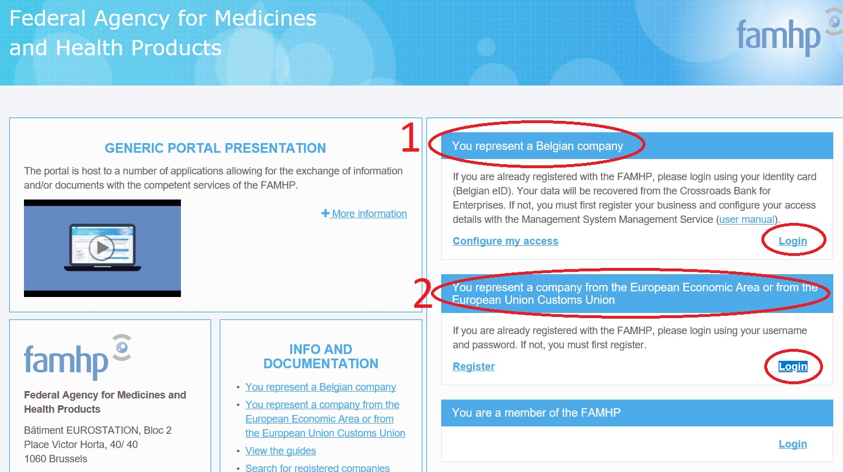

Once logged in, click on "Manage my contributions":

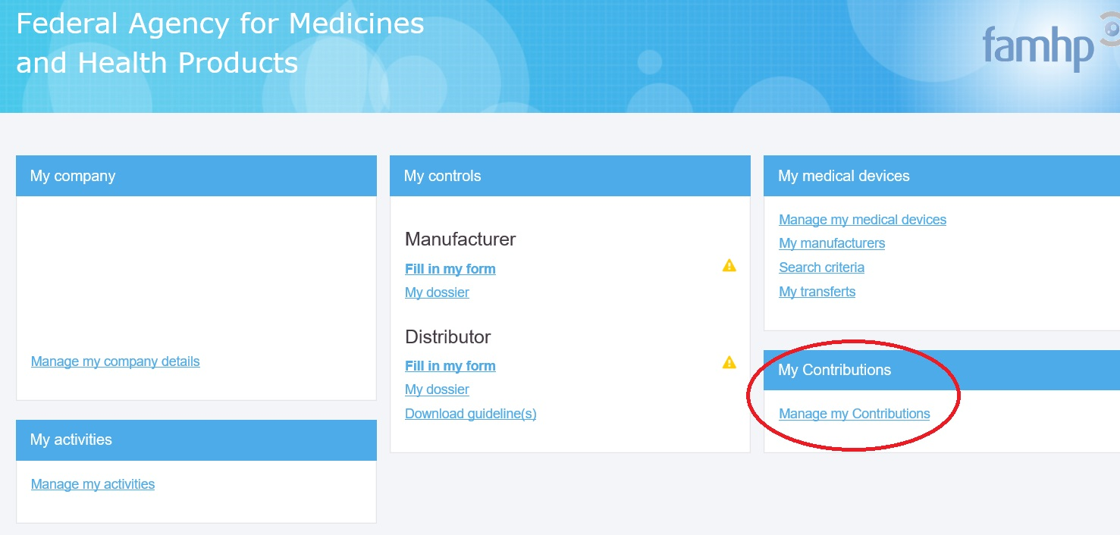

Choose "Enterprise user" and click on "Continue":

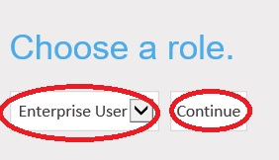

Choose the period (by default, last year considered) and click on "Declare turnover":

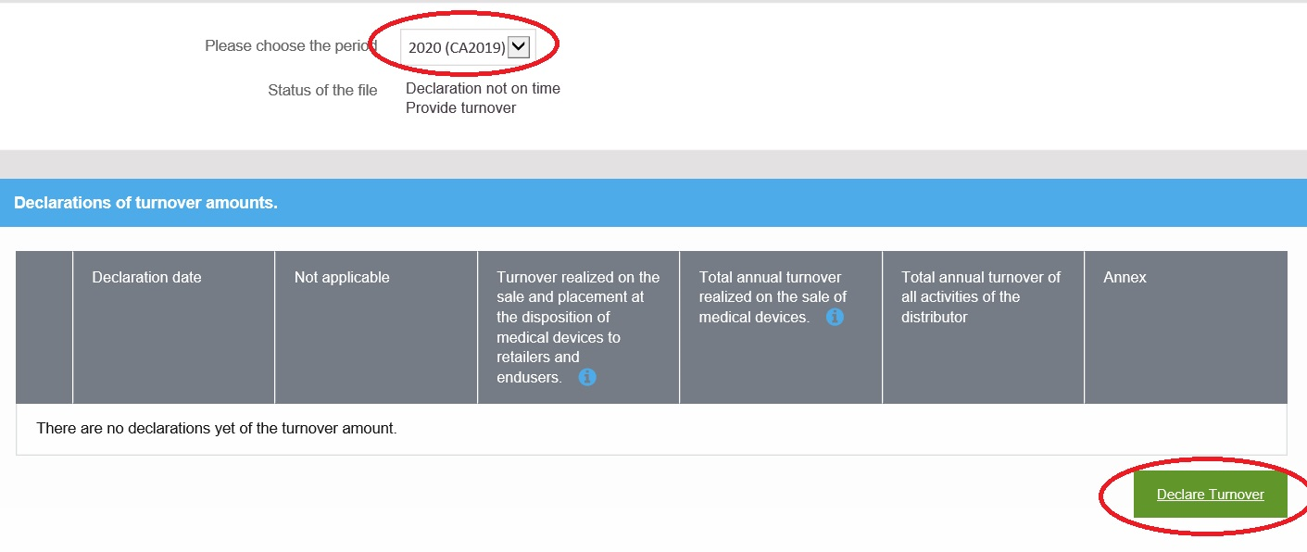

Once the electronic form opens, you have 2 possibilities depending on your case:

1: if you are not concerned by the contribution, tick the box "I do not distribute medical devices..." and then click on "Save".

2: if you are concerned by the contribution, enter the 3 amounts, click on "add a file" to upload the declaration and then click on "Save".

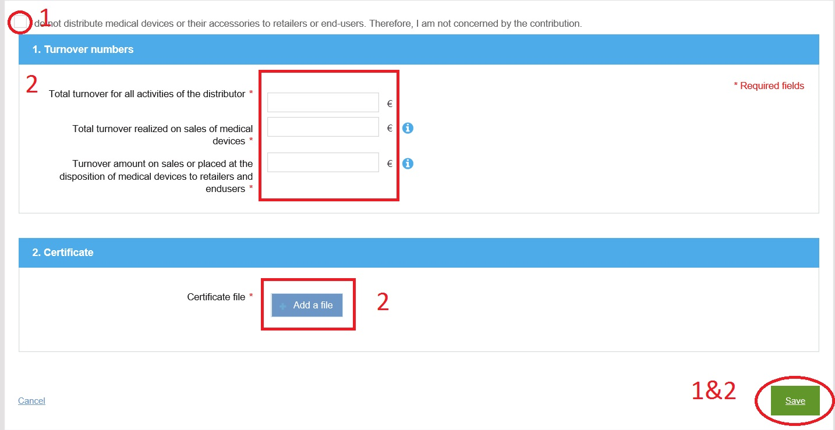

# 2. I have access to the portals but not to contributions, what should I do?

Each application requires a specific access, which means that the user who needs to access the contribution application must have the "Contribution" specific access.

To access it, the chief access manager must log in to the [social security website](http://www.socialsecurity.be) (see chapter 4 of the [manual](https://www.vas.ehealth.fgov.be/webmedseip/en/documents/famhp-portal-user-manual.pdf))

He must then check whether access to "Contributions" has been ticked for the user in question.

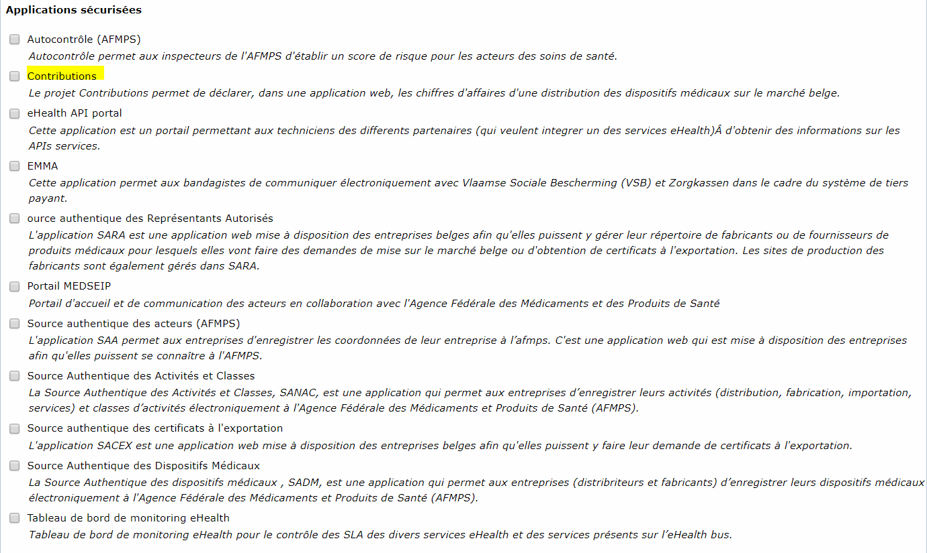

# 3. I get an error message when logging in.

* It could be a problem with the web browser. Try to log in using another browser: Mozilla, Google Chrome, Internet Explorer…
* Your profile could not be valid for access to Contributions, please refer to point 2.

# 4. How do I create a profile and access the portals?

4.1 Registration procedure for Belgian companies:

Link to the portal:  [https://www.vas.ehealth.fgov.be/webmedseip/en/](https://www.vas.ehealth.fgov.be/webmedseip/fr)

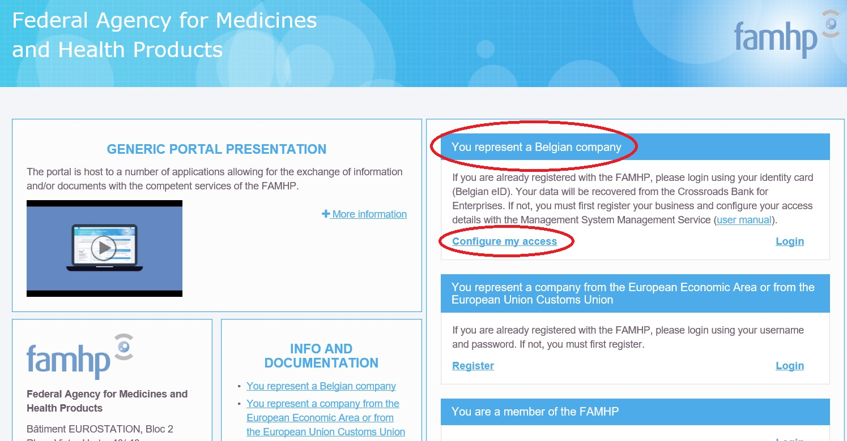

You must log in using your ID card.

**Before logging in, you will need to configure your accesses via the** [**manual**](https://www.vas.ehealth.fgov.be/webmedseip/fr/documents/famhp-portal-user-manual.pdf)**.**

Step 1: appointment of a chief file manager: <https://www.csam.be/>

Step 2: activation of quality "institution linked to the healthcare sector", link: <https://www.socialsecurity.be/>

**Your FAMHP number will be activated as soon as you enter at least one activity.**

To do so, please log back on the[**portal**](https://www.vas.ehealth.fgov.be/webmedseip/fr/)and click on "manage my activities":

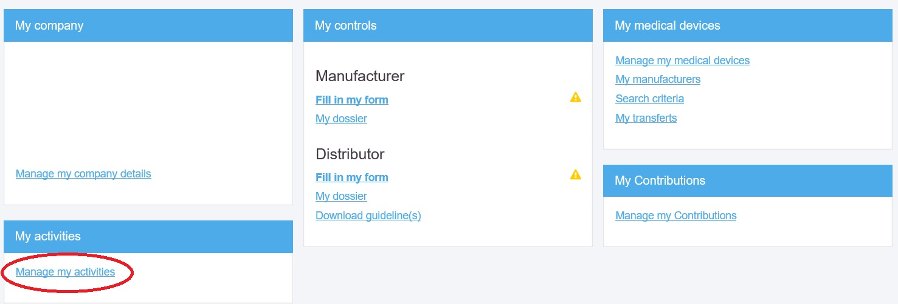

4.2 Registration procedure for Belgian companies:

Link to the portal:  [https://www.vas.ehealth.fgov.be/webmedseip/en/](https://www.vas.ehealth.fgov.be/webmedseip/fr)

You must first "register" and enter the company data:

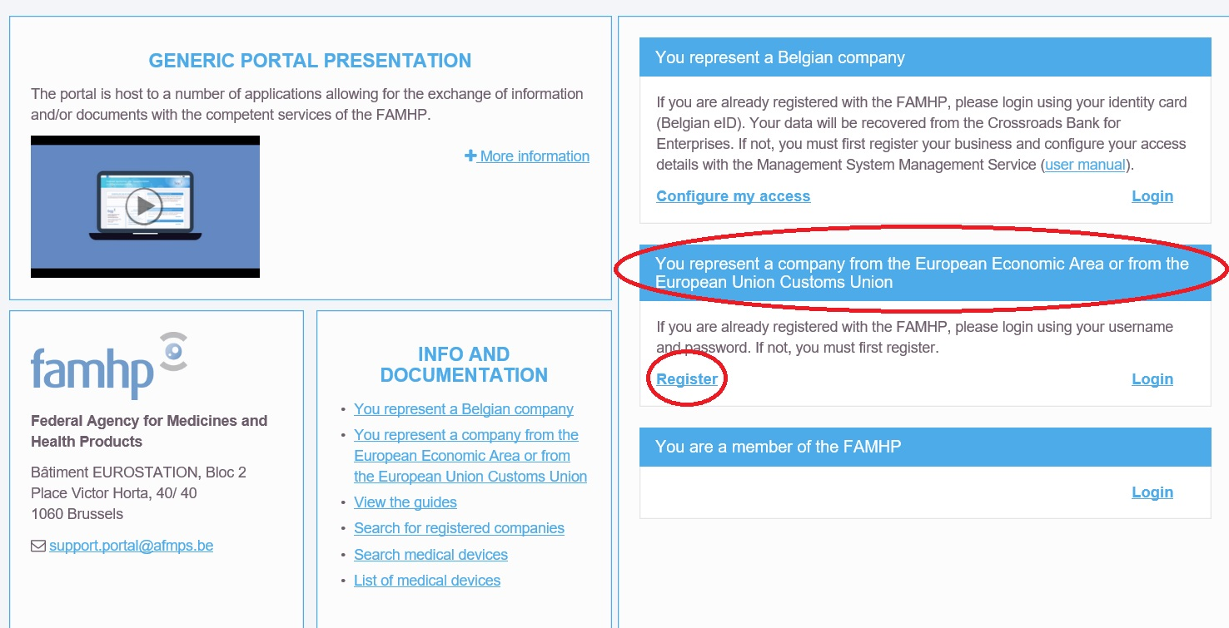

For registering company data in the web portal:

* Upload the company statutes, which must contain in particular
  + company name and address
  + name of legal persons
  + VAT number

**otherwise**  the notification will not be accepted.

The first step of your registration is completed. You must click on **"Login"** with the login and password received by e-mail in order to log in.

To do so, you need to configure your access via CSAM and Socialsecurity as explained in the email received after registering.

If you have any questions regarding access problems, please contact the Eranova centre:

* By phone 02 511 51 51
* By e-mail : [centredecontact@eranova.fgov.be](mailto:centredecontact@eranova.fgov.be)

**Your FAMHP number will be activated as soon as you enter at least one activity.**

To do so, please log back on the[**portal**](https://www.vas.ehealth.fgov.be/webmedseip/fr/)and click on "Manage my activities":

